Cary Christian School Name ____________________________________
Systematic Theology Section __________________________________
Mid-Quarter 3 Guide
____. God’s act of making otherwise estranged human beings part of God’s spiritual family by including them as inheritors of the riches of divine glory.
____. A system of theology founded on the thought of James . . . developed mainly as a response to Lutheran and especially Calvinist views on the doctrine of predestination . . . taught that predestination was based on God’s foreknowledge in seeing whether an individual would freely accept or reject Christ.
____. The doctrine that teaches the possibility of Christians’ knowing that they truly are children of God.
____. Western church’s theologian, known for his integration of the thought categories of Platonic philosophy with theology . . . asserts that God predestines those who are enabled to repent and believe.
____. The act by which God extends to humans an invitation to enter into a saving relationship.
____. Institutes of Christian Religion
____. A general term referring to an individual’s initial encounter with God in Christ resulting in the reception of God’s gracious provision of salvation.
____. In contemporary Roman Catholic theology, the idea that Mary the mother of Jesus uniquely participated in the provision of redemption.
____. refers both to the damaged relationship between God and humans and to the corruption of human nature such that there is within every human an ongoing tendency toward sin.
____. A term that describes the ability of something to fulfill the purpose for which it is made or given.
A biblical word used to speak of God’s choosing of individuals or people to bring about God’s good purposes.
____. The belief that sin is canceled out by being covered over.
____. Hearing God and doing what you are told.
____. The event in which Adam and Eve, the first humans, disobeyed the explicit command of God, thereby bringing sin and death onto the human race.
____. The term used to refer to the theological investigation of sin.
____. teaches that the Holy Spirit will work in the hearts of those whom God has chosen (the elect) such that they cannot, or at least will not, resist the saving grace God imparts.
____. refers to the divine act whereby God makes humans, who are sinful and therefore worthy of condemnation, acceptable before a God who is holy and righteous.
____. Sometimes called “particular redemption,” the view that Jesus’ death secured salvation for only a limited number of persons (the elect).
____. A Hebrew term meaning “anointed one.”
____. the state of alienation from God into which all humans are born.
____. “Presence”
____. The mandate in Scripture to remain steadfast in the love of God and to patiently endure hardship, particularly in the face of persecution.
____. The sovereign determination and foreknowledge of God.
____. A designation of the priority of God’s gracious initiative on behalf of humans.
____. The Reformation principle that declares that the privilege and freedom of all believing Christians is to stand before God in personal communion through Christ, directly receiving forgiveness without the necessary recourse to human intermediaries.
____. An offering that turns away the wrath of God directed against sin.
____. A change in relationship or attitude from enmity to peace; the cessation of hostility in attitude or action.
____. The process by which sinful humans are “bought back” from the bondage of sin into relationship with God through grace by the “payment” of Jesus’ death.
____. A biblical motif of salvation that emphasizes the rebirth or re-creation of fallen human beings by the indwelling Holy Spirit.

- Vocabulary (Matching)
  - Adoption
  - Arminianism
  - Assurance
  - Augustine
  - Call
  - Calvinism
  - Conversion
  - Coredemtrix
  - Depravity
  - Efficacious
  - Election
  - Expiation
  - Faith
  - Fall
  - Hamartology
  - Irresistible Grace
  - Justification
  - Limited Atonement
  - Messiah
  - Original Sin
  - Parousia
  - Perseverance of the Saints
  - Predestination
  - Prevenient Grace
  - Priesthood of Believers
  - Propitiation
  - Reconciliation
  - Redemption
  - Regeneration

- Fill in the Blank

- Adam and Eve heard the sound of God walking in _____________________.
- Adam and Eve said “no” to God in ____________________________.
- Mankind’s big problem is ______________________.
- ________________, or the bringing back together, between God and man first happened in the Incarnation, itself.
- Immanuel means _________ _______ ______.
- Jesus (Yeshua) means ____ __________.
- There are __________ Signs in John’s Gospel, as proposed by theologians.
- John’s Gospel is broken into what two sections by theologians:
  - Book of ____________ (_______________)
  - Book of ____________ (_______________)
- As seen in Luke _______, everything from Moses on spoke of Jesus.
- Jesus being lifted up had the two connotations of __________________ & ______________________.
- The Crucifixion has a type in the _________________ that Moses lifted up in the desert.
- The “Resurrection Passage” is ____________________________.
- Mankind is meant to ________________.

- Short Answer:
- List the Seven Signs in John’s Gospel with Scripture.

- List 4 accomplishments of the Incarnation.

- Match the following screenshots from the movie, The Gospel of John, with the appropriate chapter in John’s Gospel:

  - 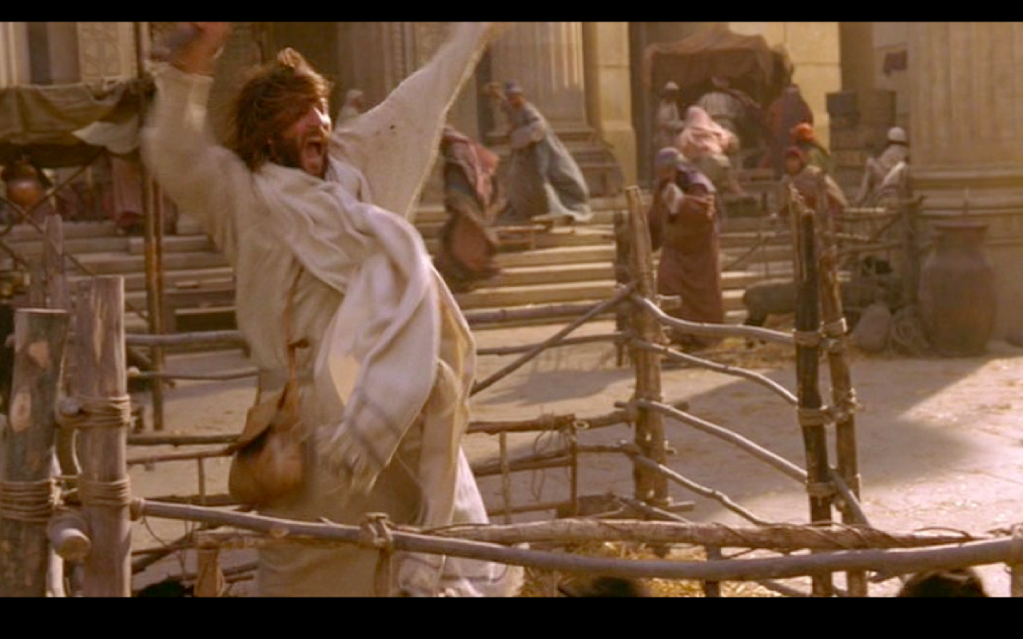
John 2 ______
John 2 ______
John 2 ______
John 3 ______
John 4 ______
John 5 ______
John 6 ______
John 8 ______
John 8 ______
“Before Abraham existed, I AM”
John 9 ______
John 11 ______
John 11 ______
John 12 ______
John 12 ______
“My hour has come.”
John 18 ______
“What is Truth?”
John 19 ______
John 21 ______

  - 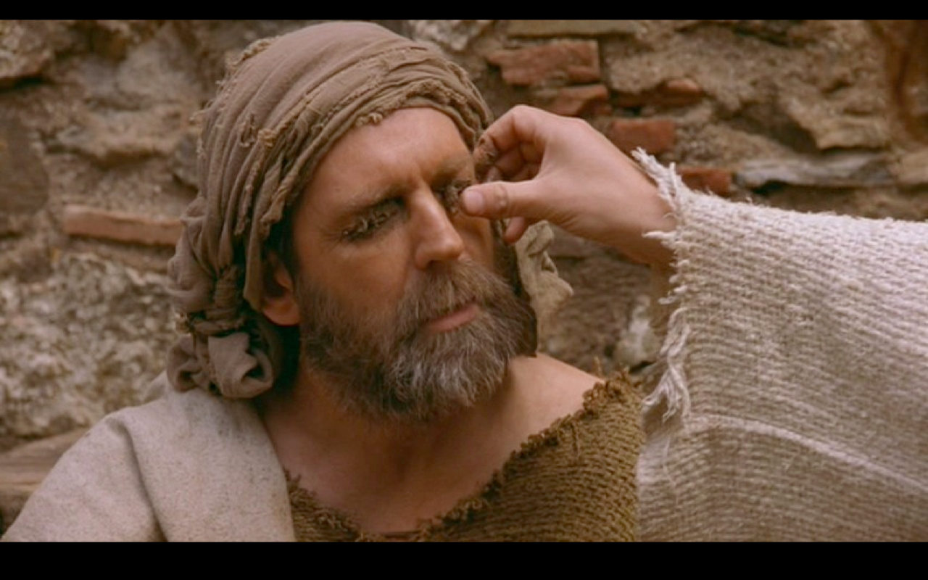
  - 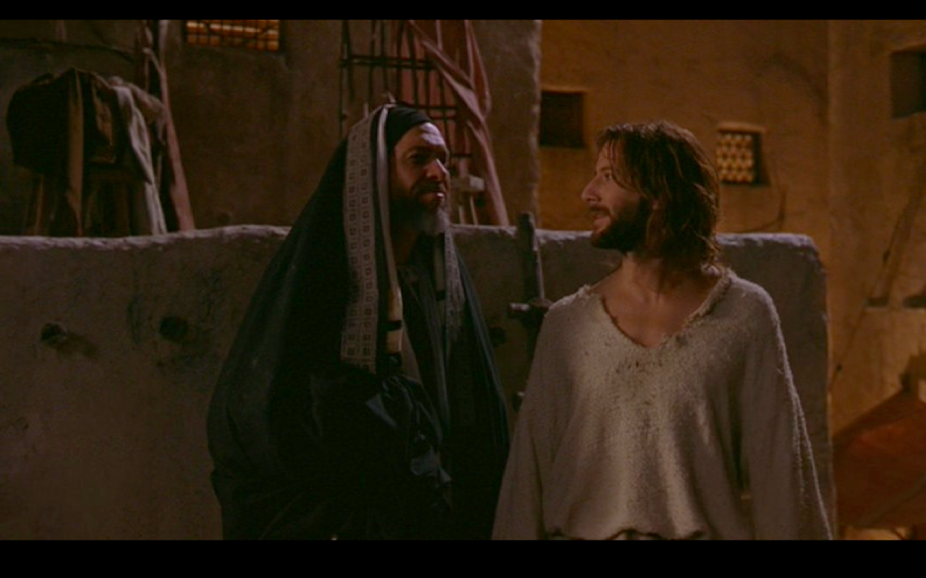
  - 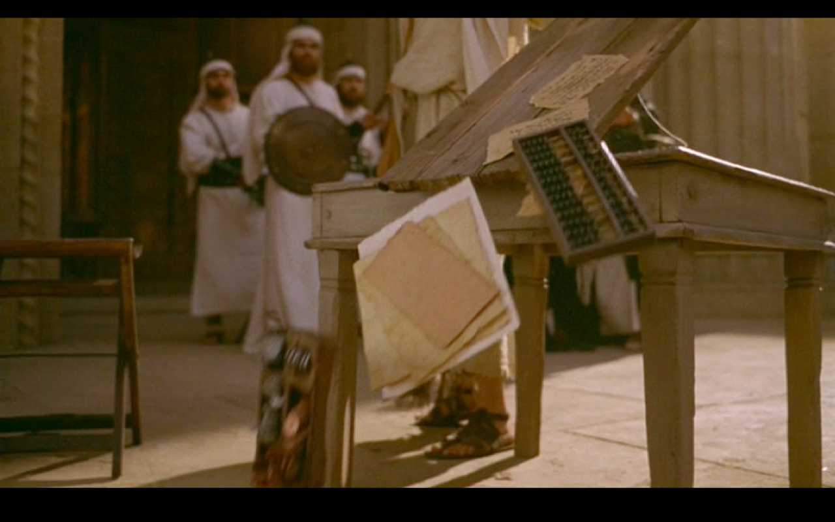

  - 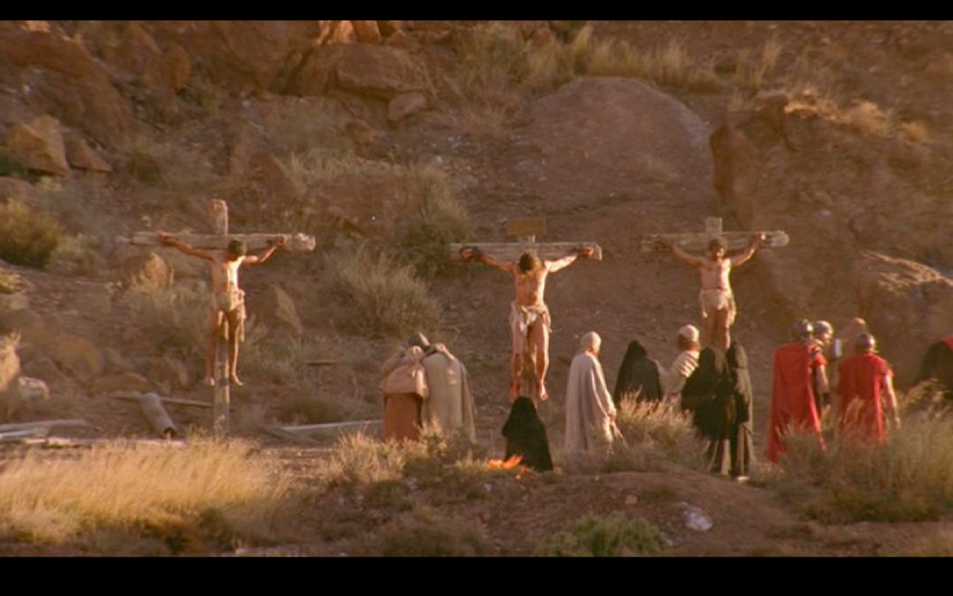
  - 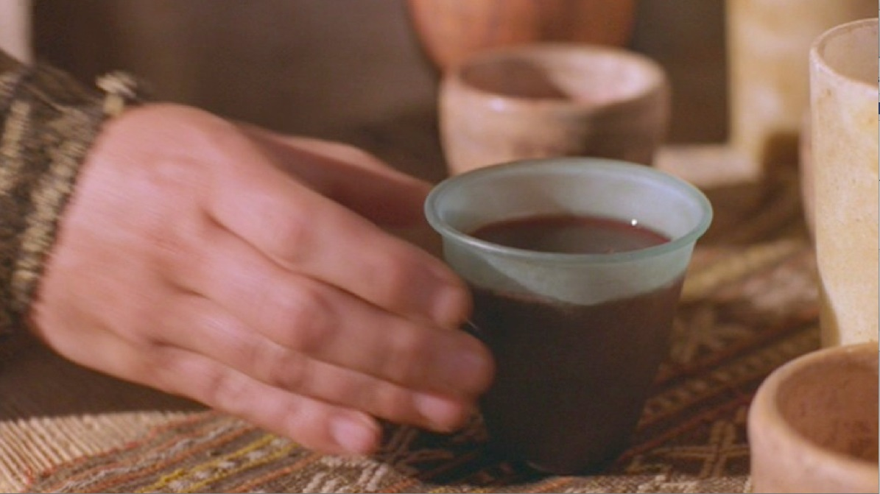
  - 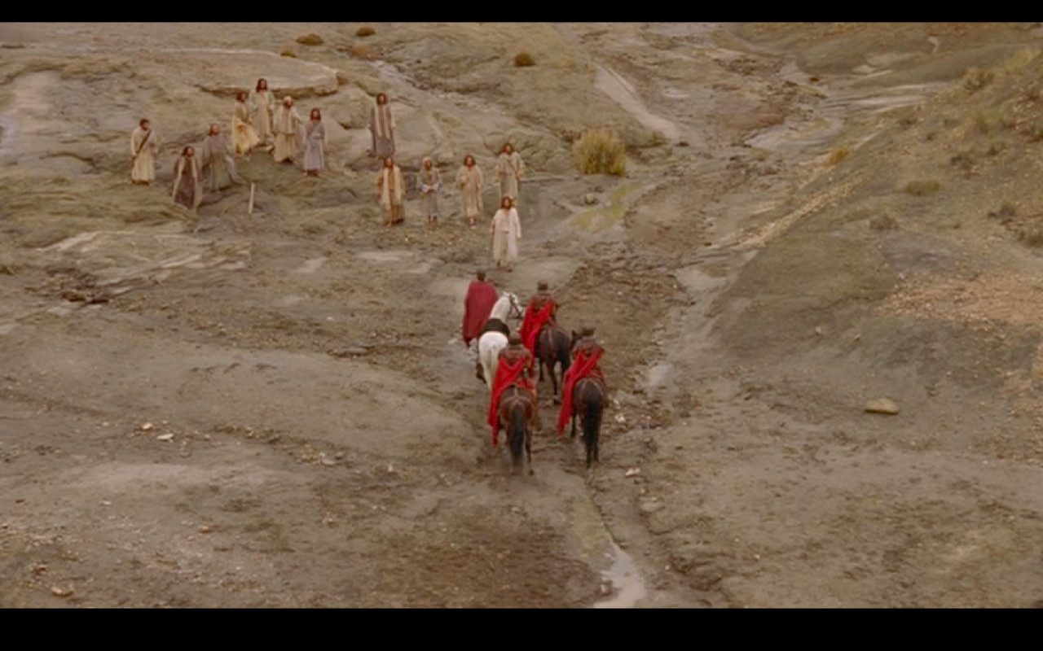
  - 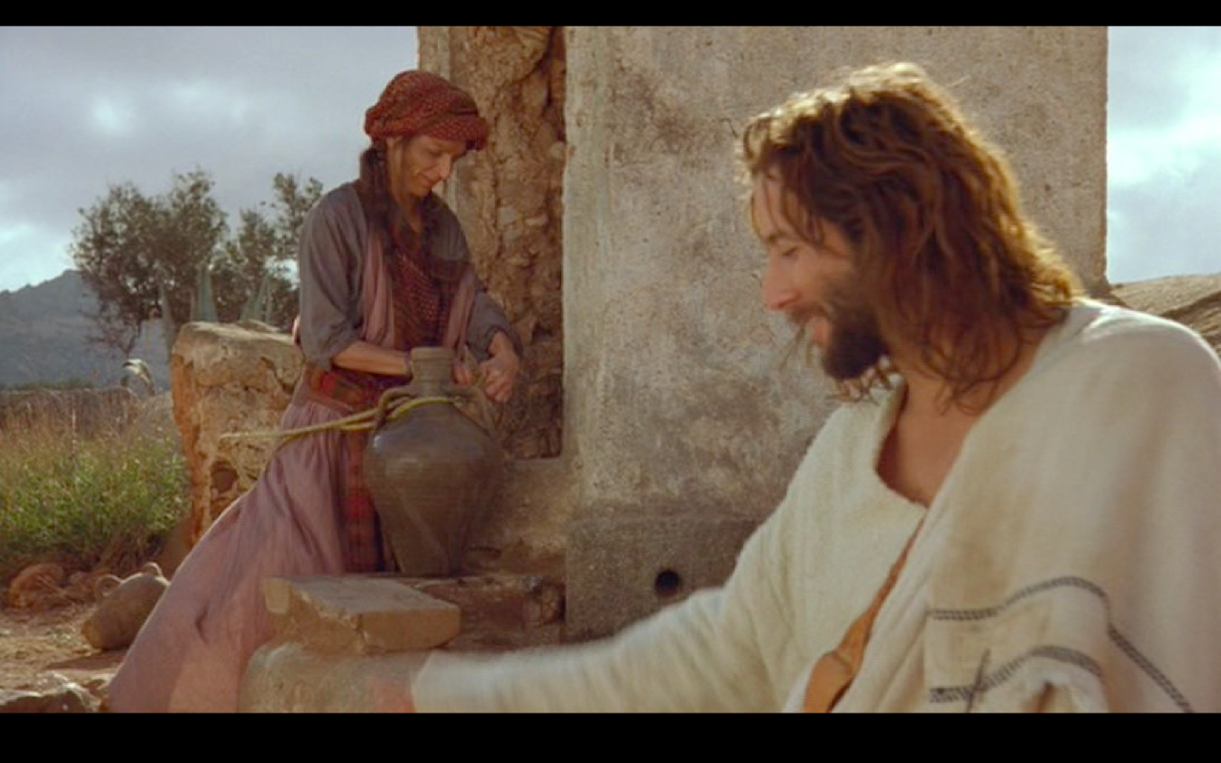
  - 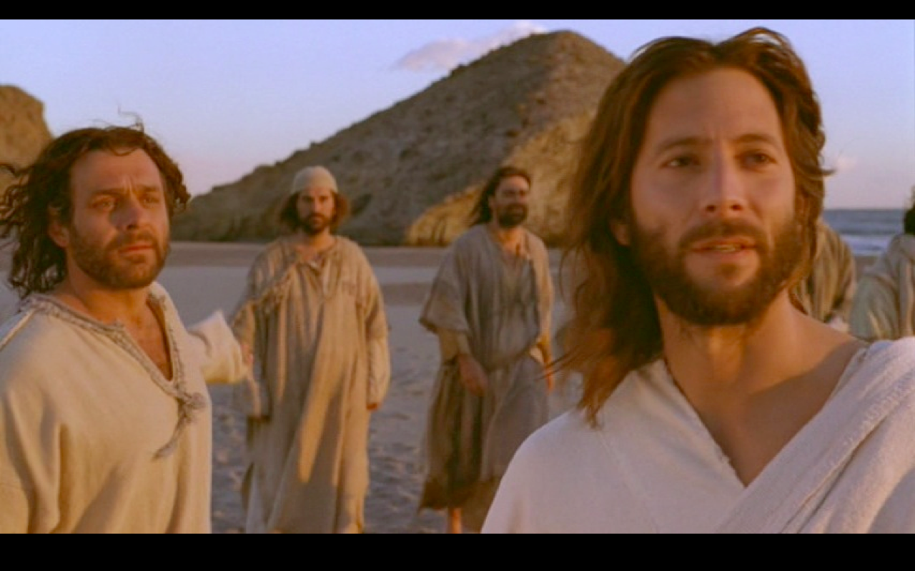
  - 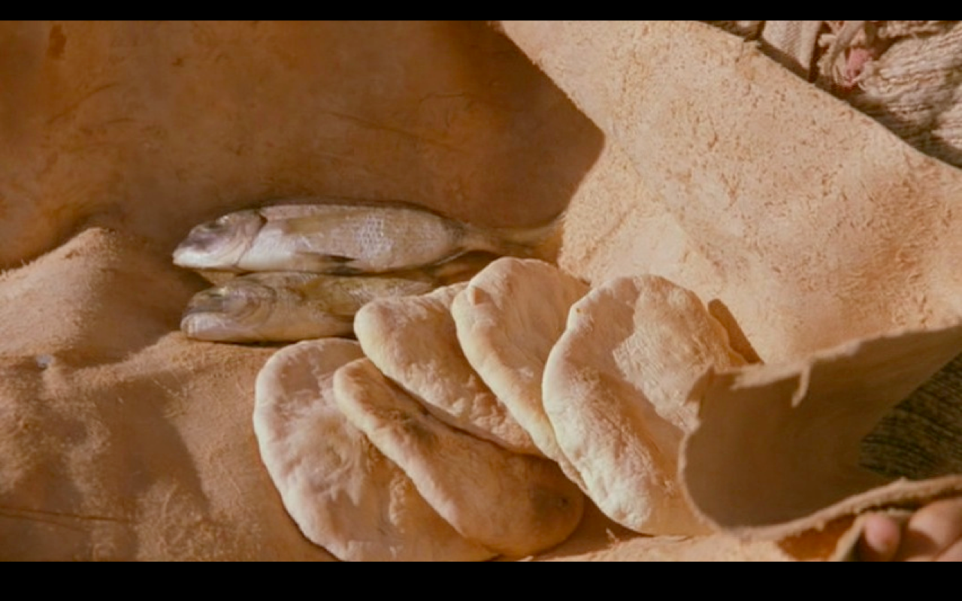
  - 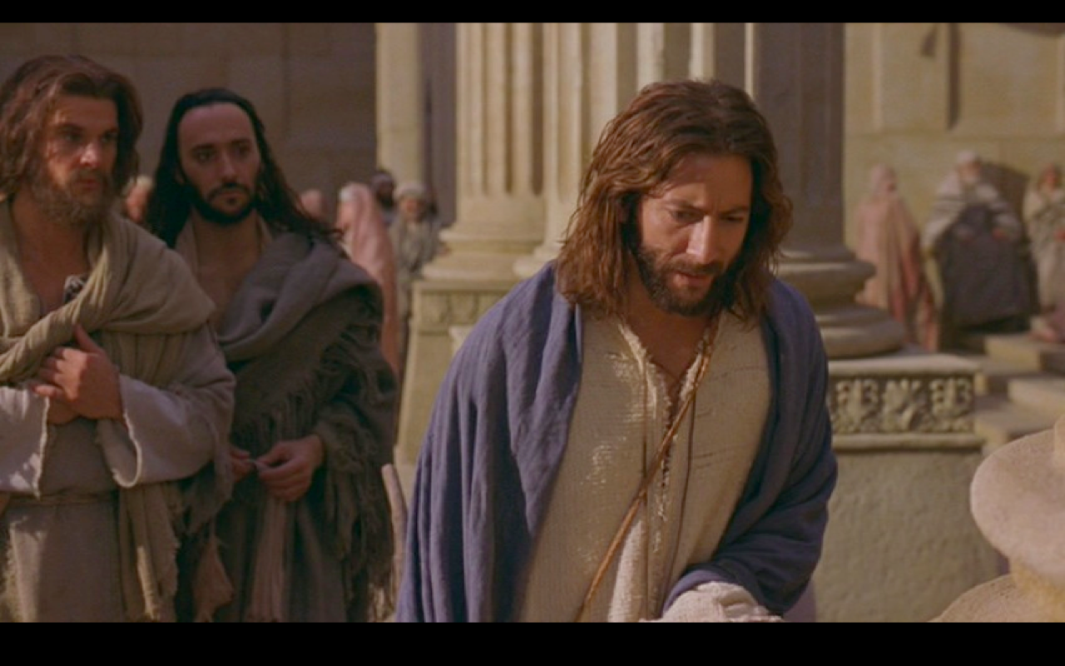
  - 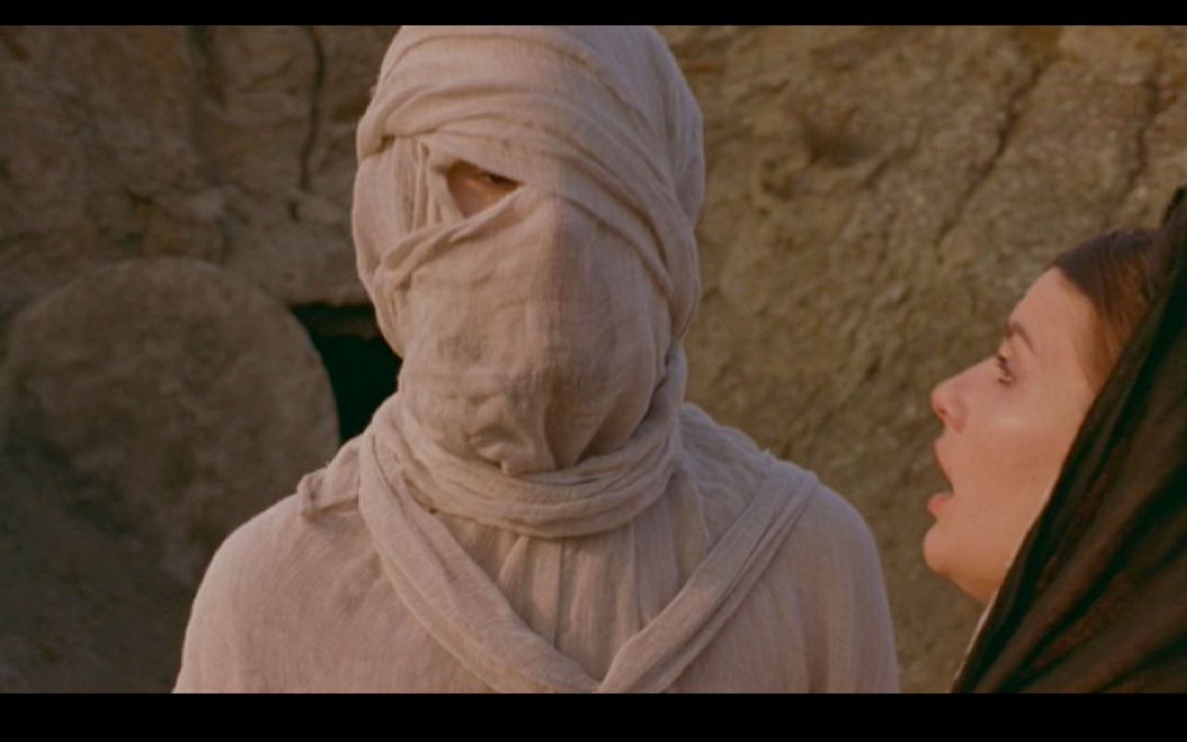
  - 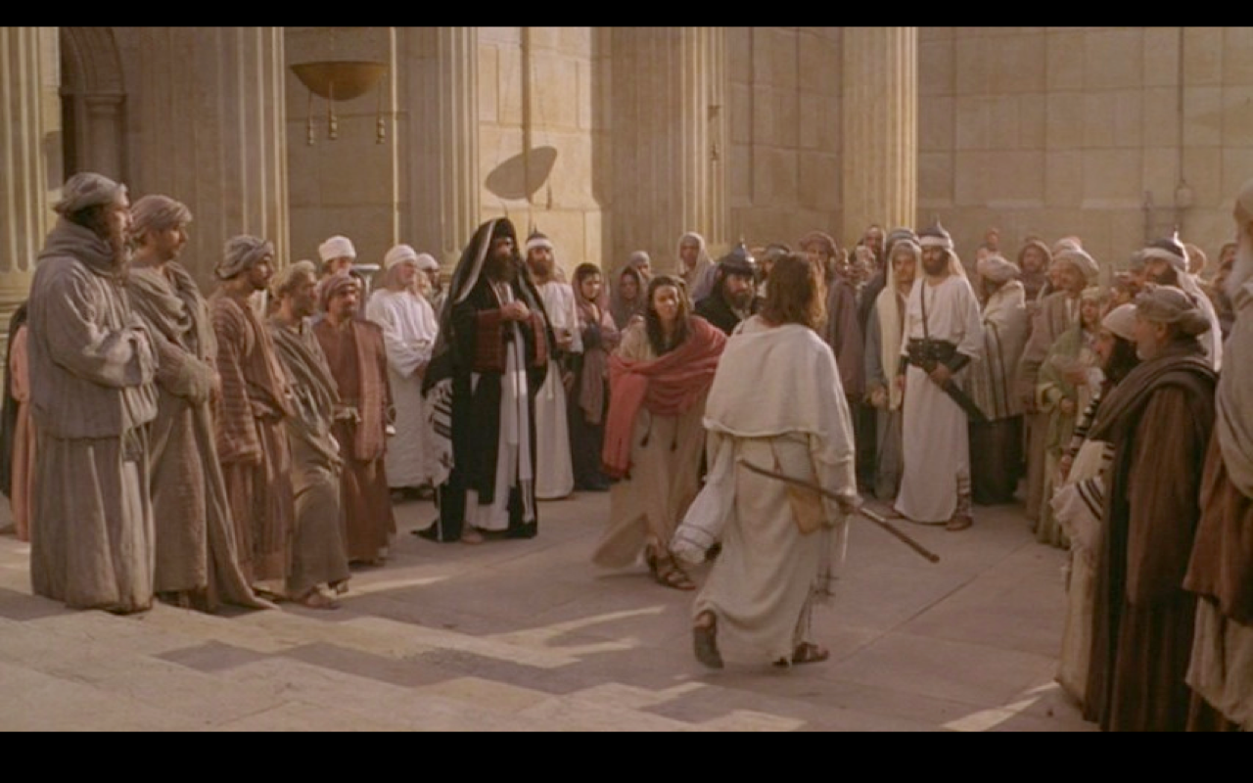
  - 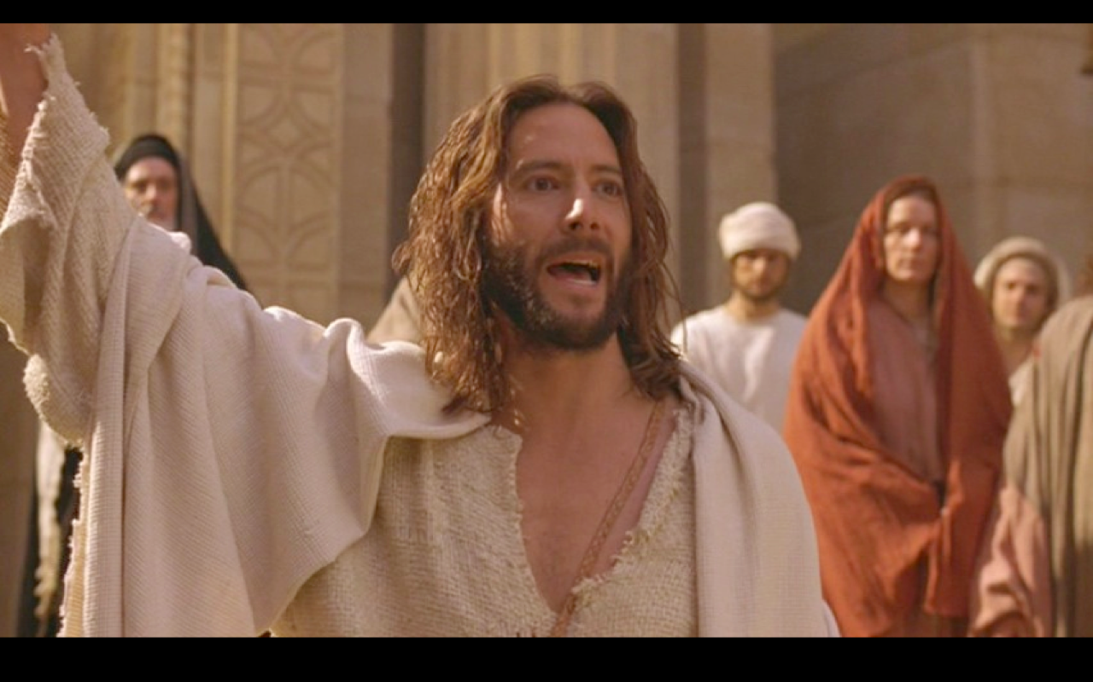
  - 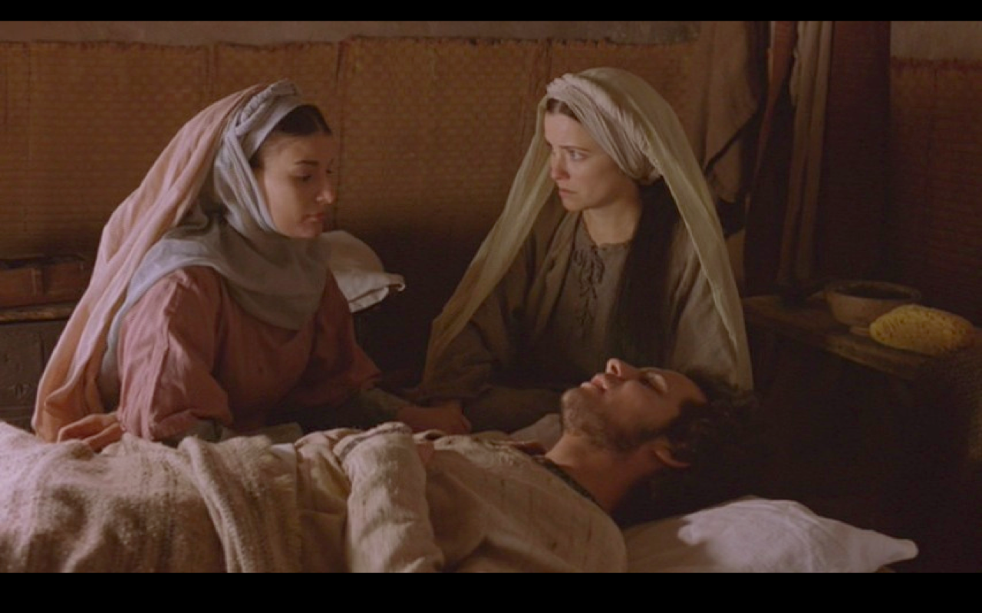
  - 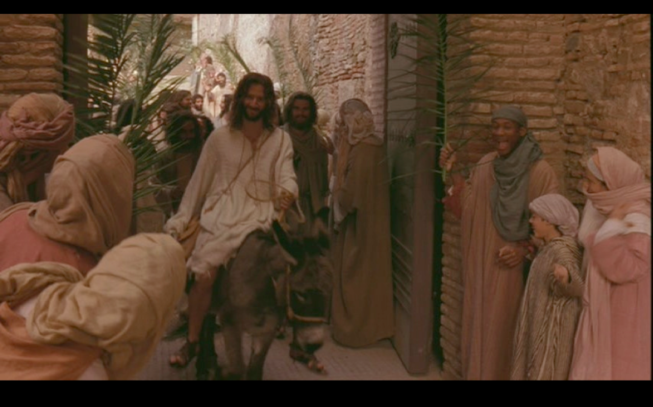
  - 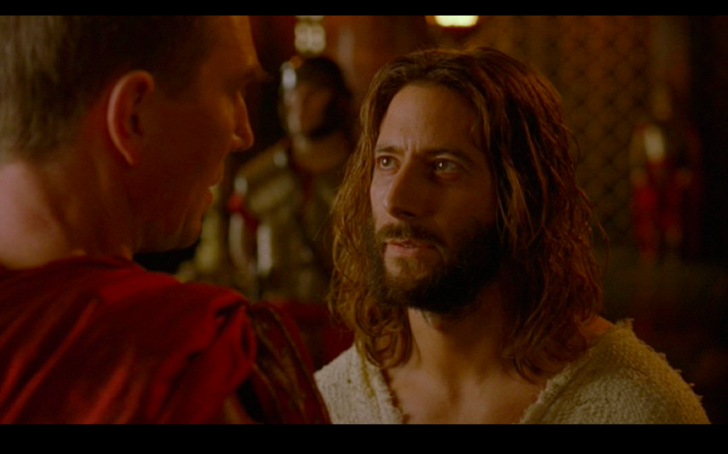

- Essay
- Draw the Big Picture Continuum.

- How was man reconciled to God in the Incarnation itself?

- Why does John use “signs” to speak of Jesus’ miracles? What is the significance of a sign?

- Explain Romans 5:10, according to the lecture.
  - For if while we were enemies we were reconciled to God through the death of His Son, much more, having been reconciled, we shall be saved by His life.
  - Explain:

- Bonus – Provide the lyrics to a verse or chorus from a song (at least 3 lines of text) that speaks of one of the doctrines we have discussed (Christology). Quote the name of the song and the lyrics.

